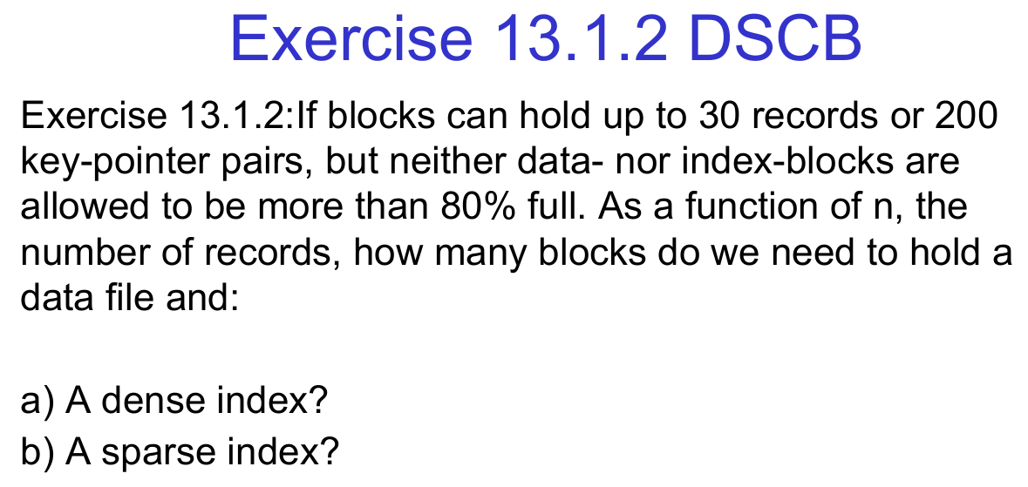

Here are three more similar questions:

Question 1a: Storage Utilization and Indexing
A disk block can hold 50 records or 300 key-pointer pairs, but both data and index blocks can only be 75% full at maximum. As a function of n (number of records), determine:
a) The number of blocks required to store the data file.
b) The number of blocks required to store a dense index.
c) The number of blocks required to store a sparse index.

Question 1b: Indexing and Storage Overhead
A database system uses blocks that can store either 40 records or 250 key-pointer pairs. The system enforces an 85% maximum utilization for both data and index blocks. Given n records:
a) Calculate the number of blocks required to store the data file.
b) Determine the number of blocks needed for a dense index.
c) Determine the number of blocks needed for a sparse index.

Question 1c: Index Size and Performance
Suppose a database uses blocks that can hold 60 records or 400 key-pointer pairs, but no block is allowed to be more than 70% full. Given n records:
a) Compute the number of blocks needed for the data file.
b) Compute the number of blocks required for a dense index.
c) Compute the number of blocks required for a sparse index.

Here are two more similar questions along with detailed solutions:

Question 1: Data and Index Block Calculation
A database system stores records and index entries in disk blocks. Each block can store up to 40 records or 220 key-pointer pairs, but the system restricts the maximum usage of any block to 75% of its capacity.
Given that the database contains n records, determine:

a) The number of blocks required to store the data file.
b) The number of blocks required to store a dense index.
c) The number of blocks required to store a sparse index.

Solution:
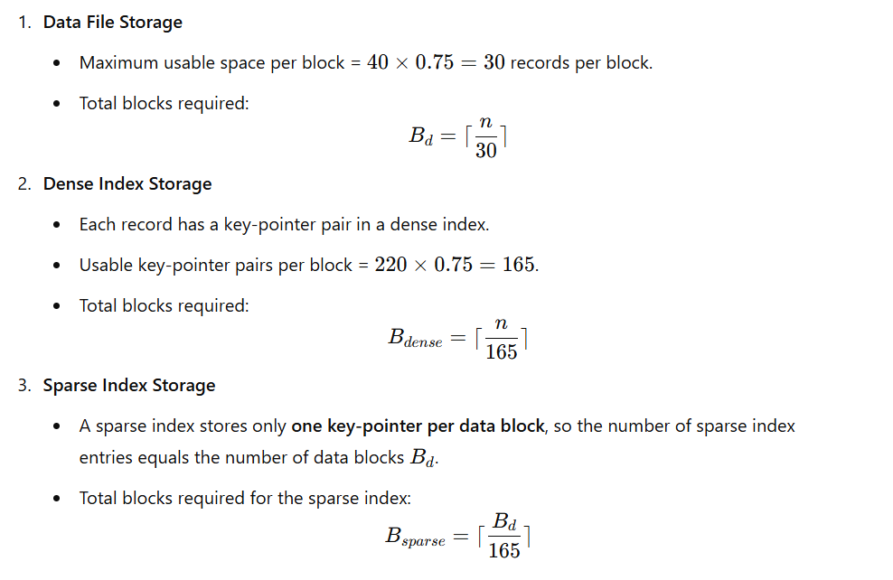

Exercise 13.1.4: Repeat Exercise 13.1.2 if we allow a multilevel indexing structure, where each level above the first reduces the number of entries to 1/50 of the previous level, until the top-level index fits in a single block. Assume n = 150,000.

Exercise 13.1.5 DSCB
Exercise 13.1.5a: Extend Exercise 13.1.2 by introducing a B+ Tree index instead of a simple index structure. Assume that each internal node of the B+ Tree can hold 150 key-pointer pairs and that a block can contain up to 40 records but is 80% full. Calculate:
a) The number of data blocks.
b) The number of index levels required to maintain a balanced B+ Tree index until only one block remains at the root level. Assume n = 200,000.

Exercise 13.1.5b DSCB
Exercise 13.1.6: Repeat Exercise 13.1.2 under the assumption that each index level is sparse, with each index entry pointing to the first record of each block in the level below. If each block holds up to 45 records, is 75% full, and index blocks store 180 key-pointer pairs, how many index levels are needed before reaching a single-block index at the top? Assume n = 120,000.

Context
- Sparse Index:
  - Has one entry per data block, not per record.
  - The key stored in the index entry typically represents the first record in that block.
- Duplicates: Multiple records in the data file may have the same search key (K) and can span multiple blocks.

Lookup Process
When you want to find all records with a specific search key K:
- Find the closest entry ≤ K
  - Search through the sparse index and find the largest key that is less than or equal to K.
  - Let's call this index entry E1.
  - This step gives you the starting block to look into.
- Move backward in the index
  - Scan backwards (towards earlier entries) until:
    - You either reach the first entry in the index, OR
    - You find an entry E2 where the key is strictly less than K.
- Identify candidate blocks
  - All index entries from E2 to E1 (inclusive) point to blocks that might contain records with the key K.
- Scan the data blocks
  - Retrieve these data blocks from disk.
  - Check the records in them sequentially until you’ve found all records with the search key K.

Example
Imagine a sparse index like this:
Index Key | Block Pointer
20 | B1
30 | B2
30 | B3
40 | B4
Search for: K = 30
- Step 1: Find entry ≤ 30 → Entry at key 30 → E1 = B3
- Step 2: Move backward → Find first entry that is < 30 → E2 = B2
- Step 3: Candidate blocks → B2, B3
- Step 4: Check both blocks for all records with key 30.

Why This is Needed
- In sparse indexes, not every duplicate key has its own entry.
- Records with the same key can span multiple blocks, so you must examine a range of blocks, not just one.

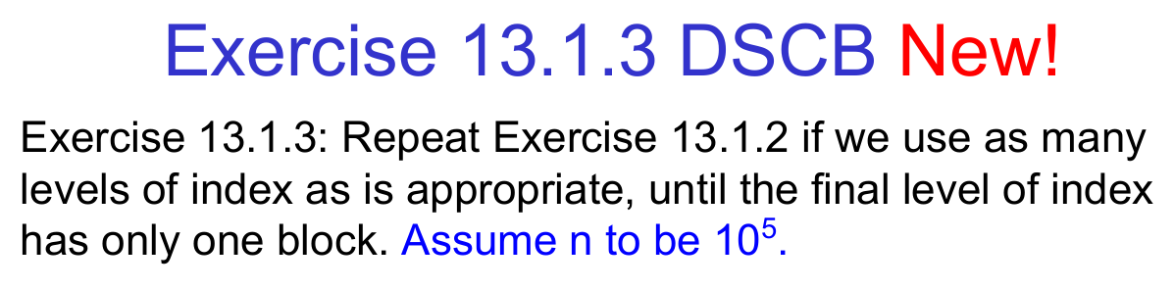

Exercise 13.1.4 DSCB
Exercise 13.1.2: Data and Index Blocks Calculation
If blocks can hold up to 30 records or 200 key-pointer pairs, but neither data nor index blocks are allowed to be more than 80% full, determine:
a) The number of data blocks required to hold n records.
b) The number of index blocks needed for a dense index.
c) The number of index blocks needed for a sparse index.
Exercise 13.1.4: Repeat Exercise 13.1.2 if we allow a multilevel index structure, where each level above the first reduces the number of entries to 1/50 of the previous level, until the top-level index fits in a single block. Assume n = 150,000.

Exercise 13.1.5 DSCB
Exercise 13.1.2: Data and Index Blocks Calculation
If blocks can hold up to 30 records or 200 key-pointer pairs, but neither data nor index blocks are allowed to be more than 80% full, determine:
a) The number of data blocks required to hold n records.
b) The number of index blocks needed for a dense index.
c) The number of index blocks needed for a sparse index.
Exercise 13.1.5: Extend Exercise 13.1.2 by introducing a B+ Tree index instead of a simple index structure. Assume that each internal node of the B+ Tree can hold 150 key-pointer pairs, and a block can contain up to 40 records but is 80% full. Calculate:
a) The number of data blocks.
b) The number of index levels required to maintain a balanced B+ Tree until only one block remains at the root level. Assume n = 200,000.

Exercise 13.1.6 DSCB
Exercise 13.1.2: Data and Index Blocks Calculation
If blocks can hold up to 30 records or 200 key-pointer pairs, but neither data nor index blocks are allowed to be more than 80% full, determine:
a) The number of data blocks required to hold n records.
b) The number of index blocks needed for a dense index.
c) The number of index blocks needed for a sparse index.
here are two new exercises (2a and 2b) written exactly in the same style and structure as your Exercise 13.1.3, each with new numeric values but same logical setup.

Exercise 2a
Repeat Exercise 13.1.2 if we use as many levels of index as is appropriate, until the final level of index has only one block.
Assume n = 5 × 10⁶ records.
Each data block holds 20 records, and each index block holds 200 key–pointer pairs.
All index blocks are 70 % full.
The data file is a sequential file with a sparse index—one pointer for each primary data block.
Each primary block has one overflow block, which is half full.
All records within a primary + overflow pair are unsorted.
Tasks
- Compute the total number of blocks required for both the data file and the multilevel index (stop when the top index level has one block).
- Determine the average number of disk I/Os required to retrieve a record given its primary key, assuming the buffer is initially empty.

Exercise 2b
Repeat Exercise 13.1.2 under the following conditions, using as many levels of index as needed until the top level has one block.
Assume n = 8 × 10⁶ records.
Each data block holds 12 records, and each index block can hold 150 key–pointer pairs, but is only 65 % full on average.
Each primary block is full and has one overflow block that is 40 % full.
The file is a sparse sequential file, and the records inside each primary–overflow pair are not sorted.
Tasks
- Compute the total number of blocks required for both the data file and the multilevel index (top index = 1 block).
- Compute the average number of disk I/Os needed to retrieve a record by its search key, assuming the search key is the primary key and no part of the index is cached.

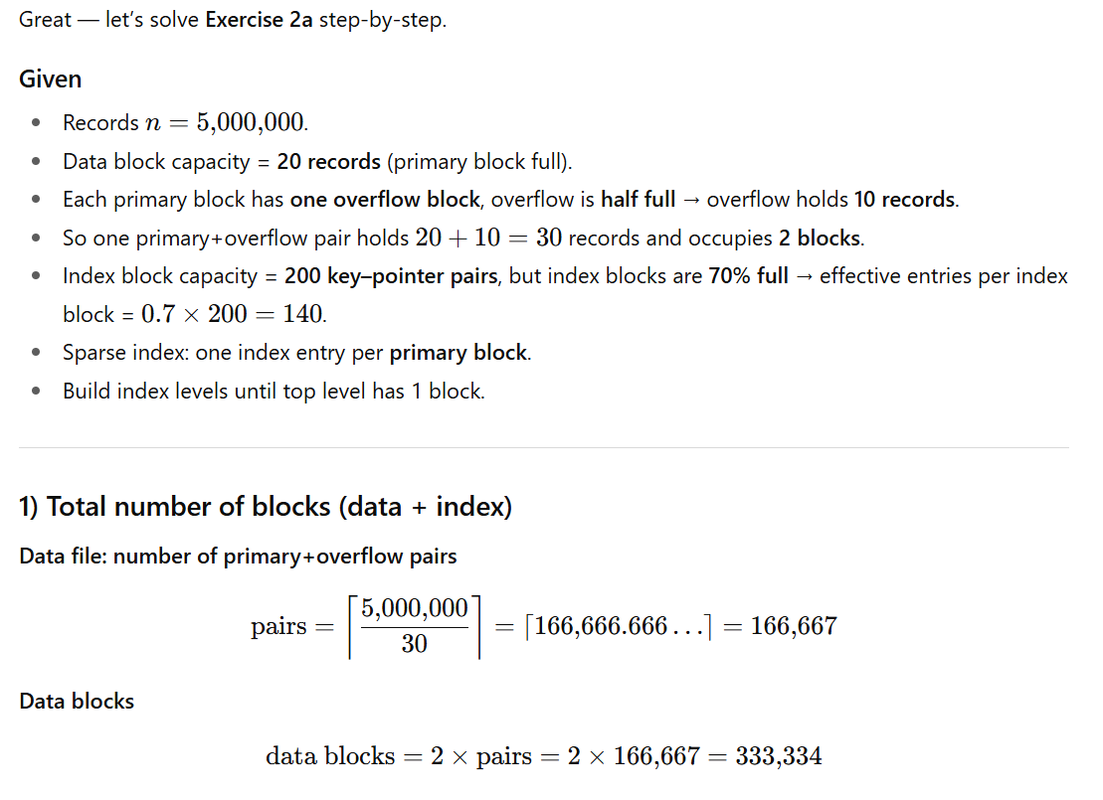
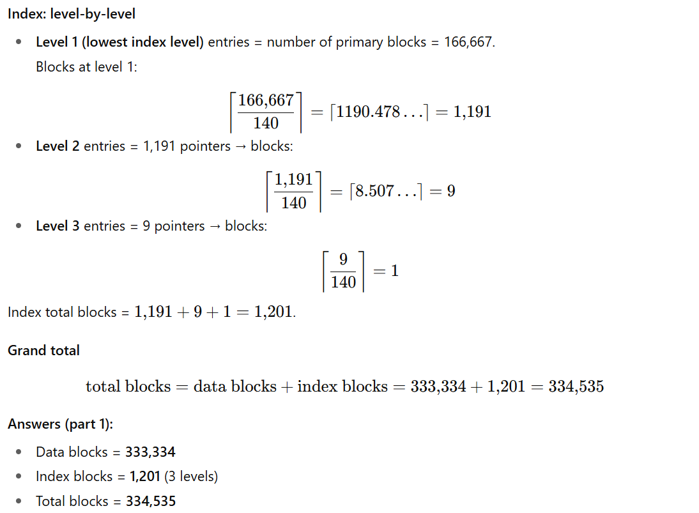
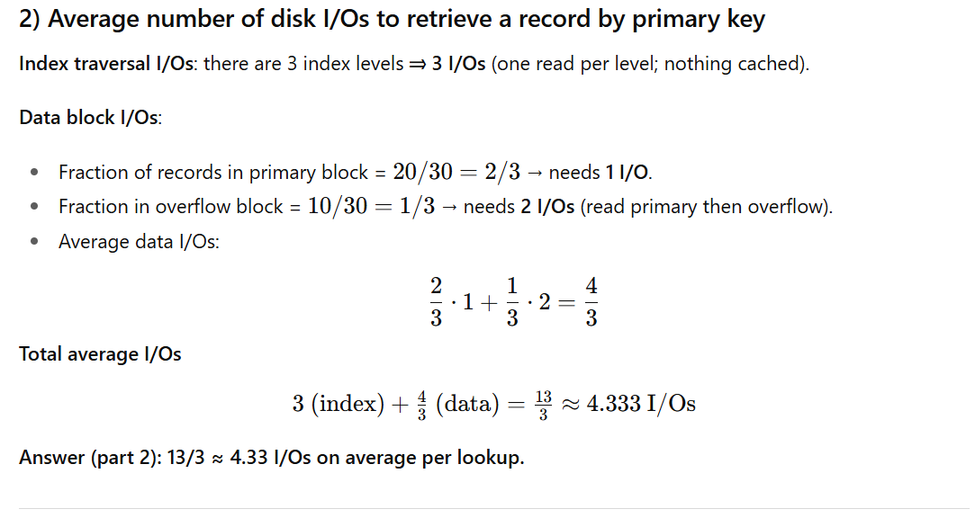

Exercise 13.1.6: Repeat Exercise 13.1.2 under the assumption that each index level is sparse, with each index entry pointing to the first record of each block in the level below. If each block holds up to 45 records, is 75% full, and index blocks store 180 key-pointer pairs, how many index levels are needed before reaching a single-block index at the top? Assume n = 120,000.

Exercise 13.1.4:
Suppose that blocks hold three records or ten key-pointer pairs but duplicate search keys are possible. To be specific, 1/3 of all search keys in the database appear in one record, 1/3 appear in exactly two records, and 1/3 appear in exactly three records. Suppose we have a dense index, but there is only one key-pointer pair per search-key value to the first of the records that has that key. If no blocks are in memory initially. Compute the average number of disk I/O's needed to find all the records with a given search key K. You may assume that the location of the index block containing key K is known, although it is on disk.

Explanation of the Given Solution
The problem in Exercise 13.1.4 asks us to calculate the average number of disk I/Os needed to retrieve all records corresponding to a given search key K. The database uses a dense index, but each search key is stored only once in the index, pointing to the first record with that key.
Given Information:
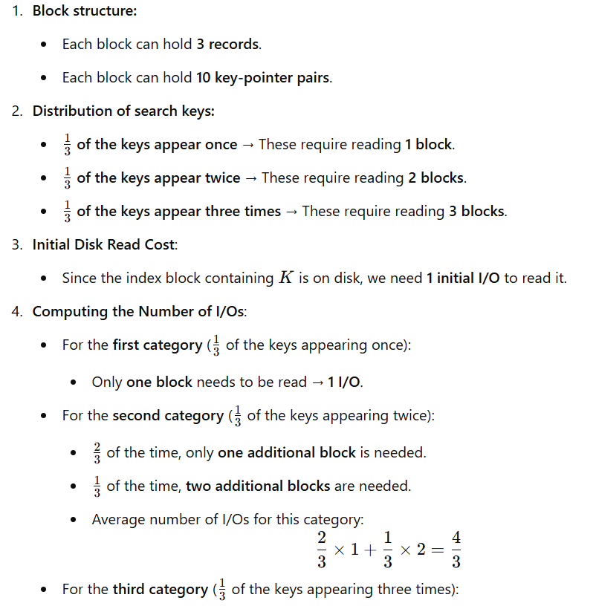
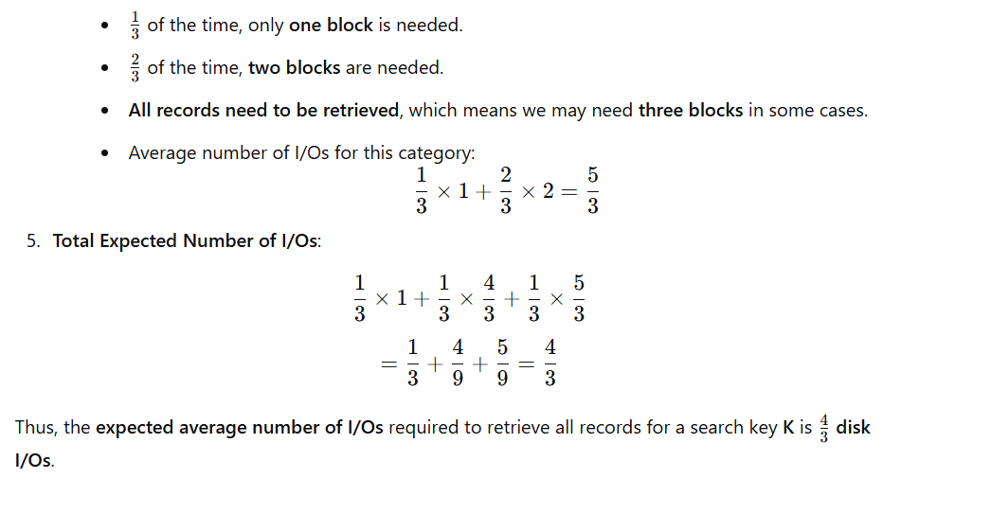

Question 1 — Skewed duplicate distribution with larger blocks
Suppose each data block can hold 5 records and each index block can hold 20 key-pointer pairs. Duplicate search keys are common:
- 50% of keys appear in 1 record,
- 30% of keys appear in 3 records, and
- 20% of keys appear in 6 records.
A dense index is built where only one key-pointer pair exists for each search key, pointing to the first record with that key.
If no blocks are in memory initially, and the index block containing key K must be fetched from disk, compute the average number of disk I/Os needed to fetch all records with that key. Assume records with the same key are stored contiguously in the data file.

Question 2 — Bucketed secondary index with duplicates
Each data block holds 4 records, and each bucket block can hold 15 record pointers. Duplicate keys are distributed as follows:
- 40% of keys appear once,
- 40% of keys appear 5 times,
- 20% of keys appear 10 times.
The system uses a bucketed secondary dense index: the index stores a pointer to the bucket block, and the bucket block contains pointers to all records with that search key. Assume nothing is cached in memory initially.
Compute the average number of I/Os to retrieve all records for a given search key K, considering:
- one I/O for the index block,
- one I/O for the bucket block, and
- enough I/Os to fetch the required data blocks (each holding 4 records) for that key.

Two More Similar Exercise 13.1.4 with Solutions
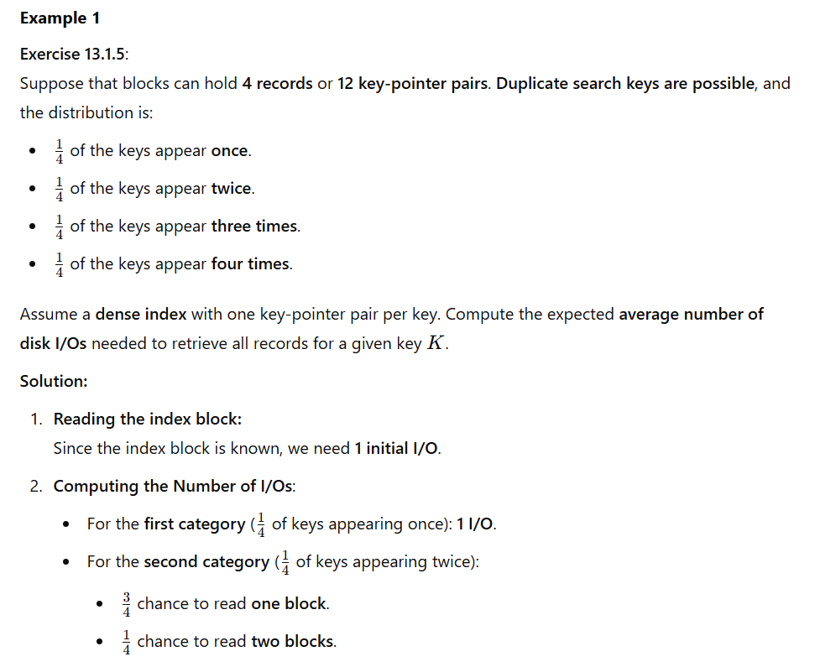
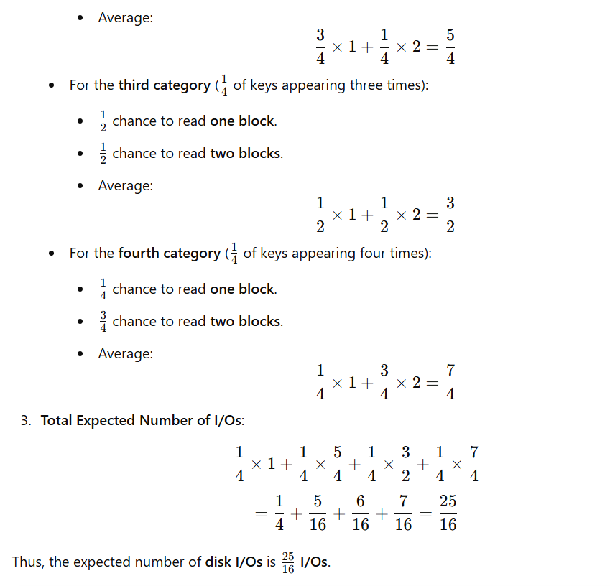

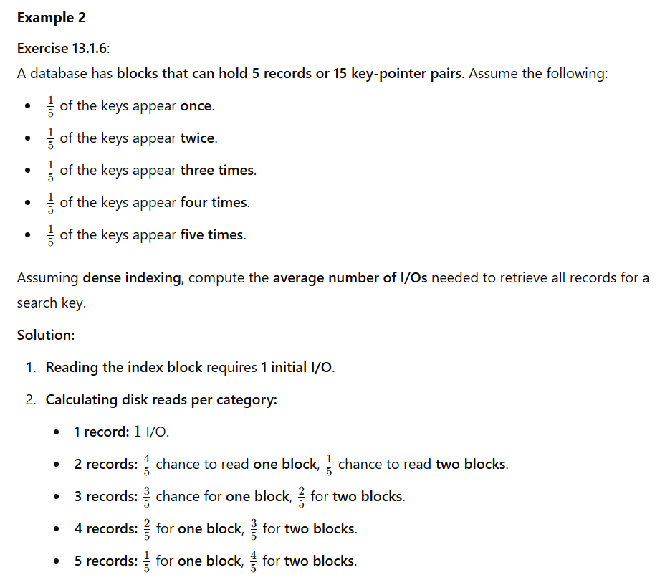
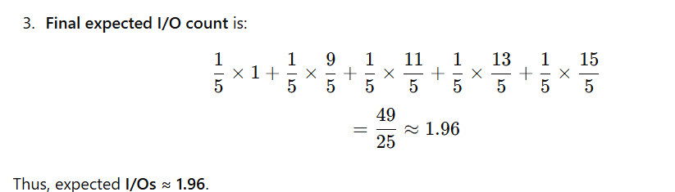
Here are three more similar exercises to Exercise 13.1.4, focusing on indexing, disk I/O, and search efficiency:

Exercise 13.1.5: Search with Duplicate Keys in a Sparse Index

Suppose that blocks hold four records or twelve key-pointer pairs, but duplicate search keys are possible.
- 1/4 of all search keys appear in exactly one record.
- 1/4 appear in two records.
- 1/4 appear in three records.
- 1/4 appear in four records.
We have a sparse index, meaning that the index only stores one key-pointer pair per block in the data file.
If no blocks are in memory initially, compute the average number of disk I/O’s needed to find all records with a given search key K, assuming that:

- The index is stored in memory.
- The index is on disk (but its location is known).

Exercise 13.1.6: Disk I/O with a Two-Level Dense Index

A file consists of n records stored in blocks that hold five records each. A dense index is used, where each index block holds 20 key-pointer pairs.
- The index is stored using a two-level hierarchy, where the top level index points to second-level index blocks, which in turn point to the data blocks.
- The location of the first-level index block containing search key K is known but is stored on disk.

Questions:
a) Compute the average number of disk I/O’s required to retrieve a record using the dense two-level index.
b) Compare this with a single-level index stored on disk.

Exercise 13.1.7: Variable-Length Records and Indexing

Suppose a database consists of variable-length records, with records ranging from 100 to 500 bytes in size.
- A disk block is 1024 bytes, and blocks are 80% full on average.
- Each block contains a variable number of records, with an average of 3 records per block.
- The database supports a dense index, where index blocks store 16 key-pointer pairs per block.

Questions:
a) How many index blocks are needed for n = 50,000 records?
b) If a query searches for a record with a given key K, what is the average number of disk I/O’s required assuming:
- The index is in memory?
- The index is on disk, but its location is known?

write three more similar exercises like this:

Exercise 13.1.4: Suppose that blocks hold three records or ten
key-pointer pairs but duplicate search keys are possible. To
be specific, 1/3 of all search keys in the database appear in
one record, 1/3 appear in exactly two records, and 1/3 appear
in exactly three records. Suppose we have a dense index, but
there is only one key-pointer pair per search-key value to the
first of the records that has that key. If no blocks are in
memory initially. Compute the average number of disk I/O's
needed to find all the records with a given search key K. You
may assume that the location of the index block containing
key K is known, although it is on disk.
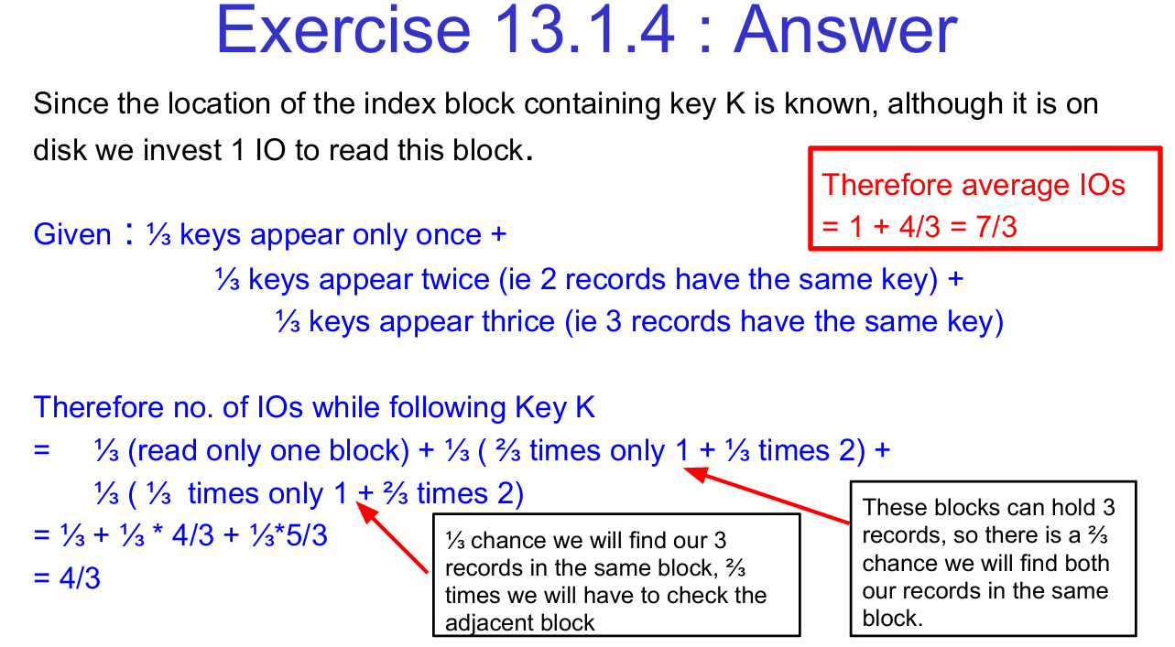

Explanation of the Solution in the Image
This exercise deals with the number of disk I/O operations needed to retrieve all records with a given search key when records are stored in blocks and indexed.
Step 1: Understanding the Given Data
- Each block can store three records or ten key-pointer pairs.
- Duplicate search keys exist, meaning multiple records may share the same key.
- Distribution of keys:
  - ⅓ of keys appear in one record.
  - ⅓ of keys appear in two records.
  - ⅓ of keys appear in three records.
- A dense index is used, where only the first record of each key is indexed.
- The index block containing the search key is known, but it is on disk, so reading it incurs 1 I/O.
Step 2: Calculating the Number of I/Os
- Reading the Index Block
Since the index block is not in memory, we must read it from the disk. This incurs 1 I/O.
- Retrieving the Records
  - For keys appearing only once:
    - The indexed record is found in one block.
    - I/Os required: 1
  - For keys appearing twice:
    - The index points to the first record’s block.
    - With probability ⅔, the second record is in the same block (no extra I/O).
    - With probability ⅓, we need to read another block.
    - Expected I/Os: ⅔ × 1 + ⅓ × 2 = 4/3.
  - For keys appearing three times:
    - The index points to the first record’s block.
    - ⅓ probability that all three records are in the same block (1 I/O).
    - ⅔ probability that we must check an additional block.
    - Expected I/Os: ⅓ × 1 + ⅔ × 2 = 5/3.

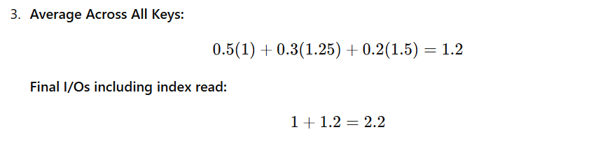

Exercise 2: Sparse Indexing and Multi-Level Retrieval
Problem Statement:
Consider a database where blocks hold five records and a sparse index is used.
- 40% of keys appear in one record.
- 40% of keys appear in two records.
- 20% of keys appear in three or more records.
Each key-pointer pair in the sparse index points to a block containing at least one record. The index block is on disk and must be read first. Compute the average I/O operations to retrieve all records for a given key.

Solution:
- Reading the Index Block: 1 I/O.
- Retrieving Records:
  - For keys appearing once: 1 I/O.
  - For keys appearing twice:
    - 80% chance both are in the same block → 1 I/O
    - 20% chance we need an extra block → 2 I/Os
    - Expected I/Os: 0.8 × 1 + 0.2 × 2 = 1.2
  - For keys appearing three or more times:
    - 50% chance they fit in one block → 1 I/O
    - 50% chance we need an extra block → 2 I/Os
    - Expected I/Os: 0.5 × 1 + 0.5 × 2 = 1.5


Exercise 3: Multi-Level Indexing with High Duplication
Problem Statement:
A database stores records in blocks, each holding three records.
- 25% of keys appear in one record.
- 50% of keys appear in two records.
- 25% of keys appear in three or more records.
A multi-level index exists, requiring an additional index lookup before accessing the data block.
Compute the total I/O operations.

Solution:
- Reading the Index Blocks:
  - First-Level Index: 1 I/O.
  - Second-Level Index: 1 I/O.
  - Total Index I/Os: 2 I/Os.
- Retrieving Records:
  - For keys appearing once: 1 I/O.
  - For keys appearing twice:
    - ⅔ chance both are in the same block → 1 I/O.
    - ⅓ chance we need another block → 2 I/Os.
    - Expected I/Os: ⅔ × 1 + ⅓ × 2 = 1.33.
  - For keys appearing in three or more records:
    - ½ chance they fit in one block → 1 I/O.
    - ½ chance an extra block is needed → 2 I/Os.
    - Expected I/Os: ½ × 1 + ½ × 2 = 1.5.


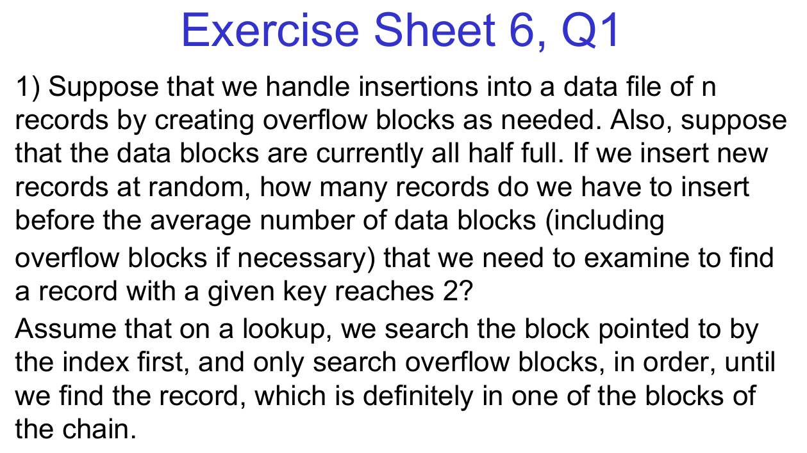

Three Similar Exercises

Exercise 6.2
Suppose that a hash-based indexing scheme is used to manage a data file containing n records. The hash table initially has B buckets, each capable of holding four records before requiring an overflow bucket. If insertions are performed randomly and uniformly, how many records must be inserted before the probability of searching an overflow bucket on retrieval reaches 0.5? Assume separate chaining for handling collisions.

Exercise 6.3
A linear hashing scheme is being used for a database with n records. Each bucket can hold up to five records before requiring an overflow bucket. If the split policy is to double the number of buckets once the average number of overflow records per bucket reaches 2, determine the total number of records required before a split occurs.

Exercise 6.4
Consider a primary index that points to data blocks where each block contains 30 records. The database initially has 100 blocks, and an overflow strategy is used where new records are inserted into overflow blocks linked to primary blocks. If records are inserted randomly and each block is initially 80% full, how many new records must be inserted before the average lookup time (in terms of blocks accessed) reaches 2.5 blocks?

Two More Exercises with Solutions
Exercise 6.5
A database consists of 1000 data records stored in primary blocks, each of which can hold 20 records. Initially, all blocks are full, so any new insertion creates overflow blocks linked to the primary block of the same key.
- Suppose records are inserted randomly into the database.
- If a search operation first examines the primary block before checking overflow blocks sequentially,
- How many records must be inserted before the expected search cost (in terms of blocks accessed) reaches 2?

Solution for Exercise 6.5:
- Understanding the Given Data:
  - Each primary block can hold 20 records.
  - Total records initially: 1000.
→ This means there are 1000 / 20 = 50 primary blocks.
  - Overflow occurs when more than 20 records are assigned to a block.
  - The search cost is 1 (primary block) + E (expected overflow blocks accessed).
- Expected Number of Blocks Accessed:
  - To have an expected search cost of 2 blocks, we need:
1+E=2
E=1
  - This means each primary block, on average, should have 1 overflow block.
- Number of Records Causing Overflow:
  - Since a primary block holds 20 records, the first 1000 records do not cause overflow.
  - Overflow starts from record 1001 onward.
  - Each block gets an overflow block when 21st, 22nd, ..., 40th records are inserted.
  - If each block receives one overflow block, this requires 1000 more records.
- Final Answer:
We need to insert 1000 additional records to reach an average lookup cost of 2 blocks.

Exercise 6.6
Consider a dynamic hashing system with initially 50 buckets, each capable of storing 5 records. When a bucket overflows, a new bucket is allocated dynamically and linked to the full bucket.
- If records are inserted randomly into the database,
- How many records must be inserted before the average number of blocks accessed per lookup reaches 2?

Solution for Exercise 6.6:
- Understanding the Given Data:
  - 50 buckets initially.
  - Each bucket can hold 5 records.
  - A search first examines the main bucket, then checks linked overflow buckets sequentially.
  - Expected lookup time = 1 + average overflow blocks searched.
  - We want this to be 2 blocks on average.
- Expected Number of Overflow Blocks per Bucket:
  - Since each bucket holds 5 records, the first 250 records (50 × 5) fit without overflow.
  - Overflow occurs from record 251 onward.
  - Each bucket gets one overflow block when it holds 6 to 10 records.
- Total Number of Records Required:
  - Each bucket will need one overflow block when an extra 250 records are inserted.
  - This means we need to insert 250 additional records after the first 250.
- Final Answer:
We need to insert 250 additional records to reach an average lookup cost of 2 blocks.

Summary
- Exercises 6.2 – 6.4 provide variations of overflow block handling scenarios.
- Exercises 6.5 – 6.6 (with solutions) demonstrate how overflow affects lookup performance.
- The key principle in all these problems is computing the expected number of overflow blocks and determining how many insertions lead to a given lookup cost.

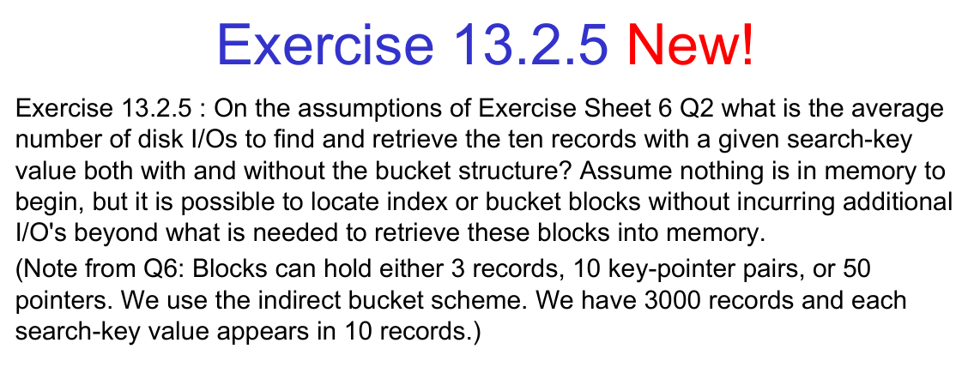

Explanation of the Solution in the Image:
The problem involves computing the number of disk I/Os needed to retrieve all records corresponding to a given search key under two different scenarios: with and without a bucket structure.
Given Data:
- Each block can hold:
  - 3 records, or
  - 10 key-pointer pairs, or
  - 50 pointers (for an indirect bucket structure).
- The database contains 3000 records, and each search key appears in 10 records.
- The index is dense and sorted.
- Indirect bucket scheme is used.
Solution Breakdown:
- With Buckets:
  - 1 I/O to read the index block containing the key.
  - 1 I/O to read the bucket block, which stores pointers to the actual records.
  - 10 I/Os to read each record block, since there are 10 records for the given key.
Total I/Os = 1 (index) + 1 (bucket) + 10 (records) = 12 I/Os.
- Without Buckets:
  - 1 I/O to read the index block.
  - 10 I/Os to read each record block directly.
Total I/Os = 1 (index) + 10 (records) = 11 I/Os.
Since the index is sorted, and one block can hold 10 key-pointer pairs, we need only 1 additional I/O to fetch the records when the pointers are stored directly.

Three More Example Exercises:
Exercise 13.2.6
On the assumptions of Exercise Sheet 6 Q3, compute the average number of disk I/Os required to retrieve 20 records for a given search key, assuming:
- We use a direct bucket structure.
- We store all pointers directly in the index.
Each block can hold 4 records, 15 key-pointer pairs, or 60 pointers in the bucket structure. We have 6000 records in total.

Exercise 13.2.7
Suppose that we store a secondary index on a file where each record appears exactly twice under different search keys. The file has 5000 records, and a block can store:
- 5 records, or
- 20 key-pointer pairs.
If a search key appears in 8 records, compute:
- The number of disk I/Os with a single-level index.
- The number of disk I/Os with a two-level index, assuming the first-level index fits in memory.

Exercise 13.2.8
Given a file with 2000 records, where each block can store 6 records or 12 key-pointer pairs, analyze the average number of disk I/Os when:
- We store pointers directly in the index.
- We use an indirect bucket scheme with 40 pointers per bucket.
Assume that a search key appears in 15 records.

Exercise 13.3.0
Consider a scenario where a B+ tree index is used for searching 50,000 records, with each leaf node storing 5 key-pointer pairs. The height of the tree is 4. Compute the number of disk I/Os required for searching and retrieving a record.
Solution:
- Searching the Key in B+ Tree:
  - Since the tree height is 4, we need 4 I/Os to reach the leaf.
- Retrieving the Record:
  - The record is located via the leaf node pointer, requiring 1 additional I/O.
Total I/Os = 4 (traversing the tree) + 1 (record retrieval) = 5 I/Os.
Nice — let’s solve it step-by-step, then I’ll give you two extra practice questions (no solutions) in the same style.

Given
- Number of records = 50,000
- Leaf capacity = 5 key–pointer pairs per leaf
- Tree height = 4 (levels including root and leaves)
Assumption: leaf pointers point to the actual record on disk (typical secondary/clustered index scenario). So retrieving a record requires reading the leaf (part of index traversal) plus one I/O to fetch the data block containing the record.

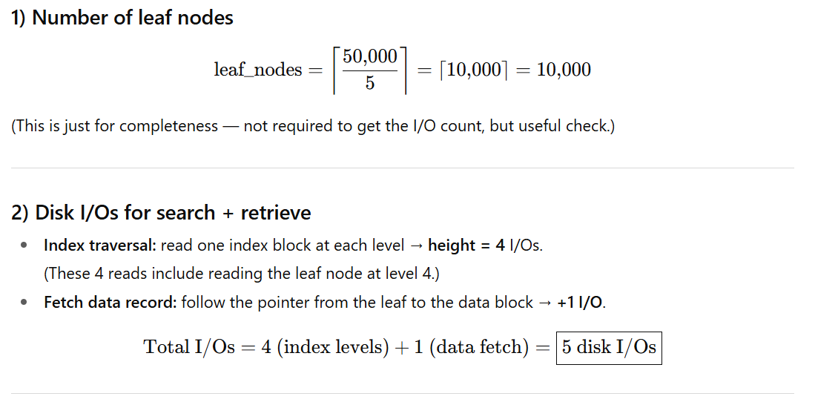

Note / alternate case
- If the index is a clustered (primary) index and the leaf actually stores the data record (i.e., records are stored in the leaf), no extra data I/O is needed beyond reading the leaf → total would be 4 I/Os.
- If some levels (e.g., root) are cached in memory, subtract those cached levels from the I/O total.

Two similar practice questions (no solutions)
Q1. A B+ tree index is used for searching 120,000 records. Each leaf node stores 8 key–pointer pairs, and the tree height is 5. Compute the number of disk I/Os required to search and retrieve a record (assume nothing cached and leaf pointers reference data blocks).
Q2. A B+ tree indexes 75,000 records. Each leaf holds 6 key–pointer pairs. The tree height is 3. How many disk I/Os are needed to search and retrieve a record if (a) the index is secondary (leaf → pointer to data block) and (b) the index is clustered (leaf holds the full record)? (Assume no caching.)

These mirror the format and difficulty of DBMS exam problems (conceptual + calculation-based).

🧩 Question 1 — Records per Leaf and I/Os (Secondary Index)
A B+-tree index is used to organize a data file of 120 000 records.
Each leaf node of the index can store 200 key–pointer pairs, and each data block can hold 50 records.
The tree height (including root and leaves) is 4.
Assume:
- Every index node (including leaves) occupies one disk block.
- Each pointer in the leaf points to the data block containing the record (unclustered/secondary index).
- Nothing is cached in memory initially.
Tasks
a) Compute the number of leaf nodes in the index.
b) Compute the total number of I/Os required to search for and retrieve a single record using this index.
c) If the root and the next level of the index are cached, how many I/Os would be needed on average?

🧩 Question 2 — Leaf Capacity, Height, and Access Cost (Clustered Index)
A clustered B+-tree is used to index a relation of 1 000 000 records.
Each leaf node stores 100 records directly (not pointers).
Each internal node can store up to 250 key–child-pointer pairs, and the tree has five levels (including root and leaves).
Assume each node is one disk block, and nothing is cached at first.
Tasks
a) Determine how many leaf nodes (blocks) are required.
b) Compute the minimum and maximum number of I/Os needed to retrieve one record.
c) If the top two index levels are cached in main memory, how many I/Os are needed to access a record?

🧩 Question 1 (re-stated)
- Total records = 120 000
- Each leaf node = 200 key–pointer pairs
- Each data block = 50 records
- Tree height = 4 (root + 2 internal levels + leaves)
- Unclustered (secondary) index → leaf pointers reference data blocks
- Nothing cached in memory initially

🔹 (a) Number of leaf nodes
Each leaf entry = one record pointer → 1 entry per record.

✅ 600 leaf nodes

🔹 (b) Disk I/Os to search + retrieve one record

Step 1: Index traversal
Height = 4 → read one node per level:
- Root
- Level 2 internal node
- Level 3 internal node
- Leaf
4 I/Os for index traversal

Step 2: Data record fetch
Since this is a secondary index, the leaf entry contains a pointer to the actual data block.
→ 1 extra I/O to read that data block.
✅ 5 disk I/Os required

🔹 (c) If the root and next level are cached
Cached levels = root + 1 internal level → 2 levels.
Remaining levels on disk:
- Level 3 internal node
- Leaf node
→ 2 I/Os for index traversal.
Then add 1 data I/O:
✅ 3 disk I/Os when top 2 levels cached

✅ Final Answers Summary
Part | Description | I/Os / Blocks
(a) | Leaf nodes needed | 600 blocks
(b) | Search + retrieve (no cache) | 5 I/Os
(c) | Search + retrieve (with top 2 levels cached) | 3 I/Os

solved Question 2 (Clustered Index) step-by-step — just like an exam answer.🧩 Question 2 (re-stated)
A clustered B+ tree is used to index a relation of 1,000,000 records.
Each leaf node stores 100 records directly (clustered — not pointers).
Each internal node can store up to 250 key–child-pointer pairs.
The tree has five levels (including root and leaves).
Each node (internal or leaf) is one disk block.
Nothing is cached initially.

🔹 (a) Number of leaf nodes (blocks)
Each leaf node holds 100 records.
✅ 10,000 leaf nodes

🔹 (b) Minimum and maximum number of I/Os to retrieve one record

Background
- In a clustered B+ tree, data records are stored directly in the leaf nodes.
- Therefore, retrieving a record = traversing from the root to the leaf node containing it.
- Each level corresponds to reading one block (1 I/O) if nothing cached.

Given:
Height = 5 (root → 3 internal levels → leaf).

Maximum I/Os
If nothing is cached, we must read one block per level:
Max I/Os = 5
✅ Maximum = 5 disk I/Os

Minimum I/Os
If higher levels are cached (best case):
- All internal levels (root + intermediates) are already in memory.
- Only need to read the leaf block containing the desired record.
Min I/Os = 1
✅ Minimum = 1 disk I/O

Optional intermediate case (partial caching)
If, for example, the root and first internal level are cached:
- You still need to read 3 index blocks (the remaining internal levels and the leaf).
I/Os = 3 + 1 = 4
(but we stick to the required min/max extremes for the exam).

✅ Final Answers Summary
Part | Description | Result
(a) | Leaf nodes | 10,000
(b) | Minimum I/Os (if internals cached) | 1
(b) | Maximum I/Os (nothing cached) | 5

🧠 Concept Check
Concept | Explanation
Clustered index | Leaf contains actual records; no separate data fetch.
Tree height | Number of levels from root to leaf; one block per level read = one I/O each.
Caching | Reduces I/Os by keeping upper levels in main memory.

“There are 100 leaf nodes in a B+ tree. What are the minimum and maximum number of disk I/Os required to retrieve one record?”

🔹 Step 1 — Recall B+ tree access process
When searching for a record:
- Start at the root.
- Follow pointers through each internal node.
- Reach the leaf node containing the key.
- If clustered, the record is in that leaf block.
- If secondary (unclustered), follow a pointer to the data block.
Each block read from disk counts as one I/O.

🔹 Step 2 — Determine tree height (h)
We’re told:
- There are 100 leaf nodes in total.
- But not the fan-out (branching factor).
That means the tree has 2 levels:
- Level 1: Root
- Level 2: Leaf nodes (100 leaves)

🔹 Step 3 — Compute I/Os

Case 1 — Clustered B+ Tree
- Data records are stored in the leaf node.
- So, you only need to read each level once.

Maximum (no caching)
→ Read root + leaf = 2 I/Os

Minimum (root cached)
→ Only need to read the leaf block = 1 I/O
✅ Clustered Index
Condition | I/Os
Max (no caching) | 2
Min (root cached) | 1

Case 2 — Secondary (Unclustered) B+ Tree
- The leaf stores a pointer to a data block containing the record.
- After reaching the leaf, you must also fetch the data block.

Maximum (no caching)
→ Root + leaf + data block = 3 I/Os

Minimum (root cached)
→ Leaf + data block = 2 I/Os
✅ Unclustered Index
Condition | I/Os
Max (no caching) | 3
Min (root cached) | 2

🔹 ✅ Final Summary
Type of Index | Tree Height (Levels) | Minimum I/Os | Maximum I/Os
Clustered (data in leaf) | 2 | 1 | 2
Secondary (pointer in leaf) | 2 | 2 | 3

💡 Key takeaway:
- Minimum I/Os occur when upper levels (like the root) are cached.
- Maximum I/Os = one read per level (root → leaf) + possible data block read (if secondary).

